EDISON X
TECHNOLOGIES
PURPOSE | TOOLS
Logical Reasoning | Groz (llama 3.3)
Data Extraction | Doc Sumo,(party,judge,next hearing) or Base 64 Ai,fitz
Automation | Selenium Script (or) Playwrite+Tesseract
Image Extraction | OCR & Tessaract
Pattern Matching Engine | Matching engine (llama 3.3) Spacy
Multilanguage | Flutter,MT5

WEB CONNCTION
1.NJDG or Indian Kanoon or Madras High Court or MHC
2.Loan details (mock data)
3.Land details laike Patta,Chitta (mock data)

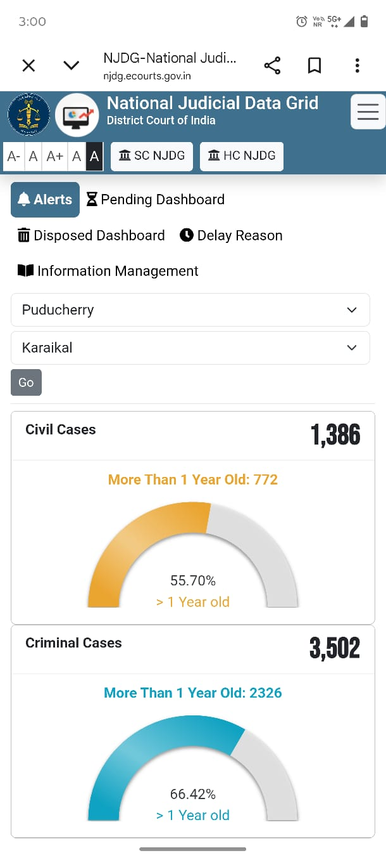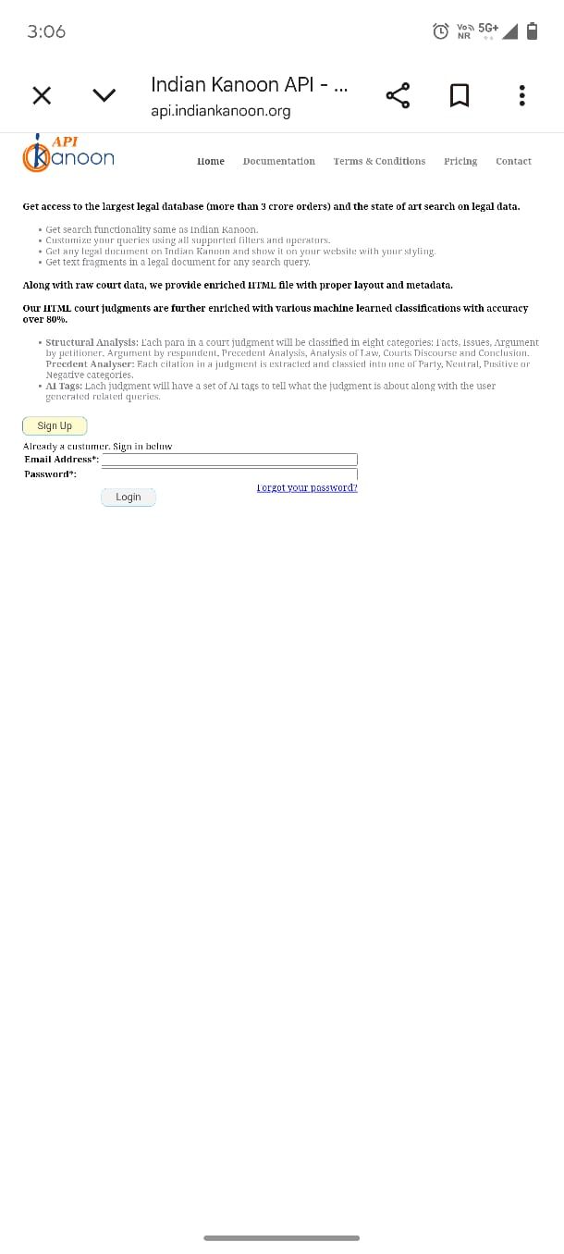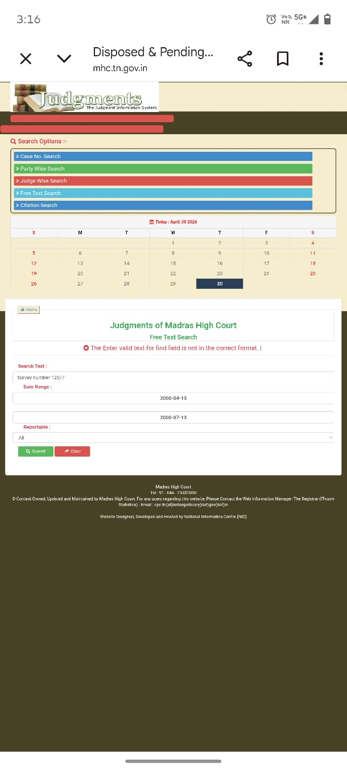
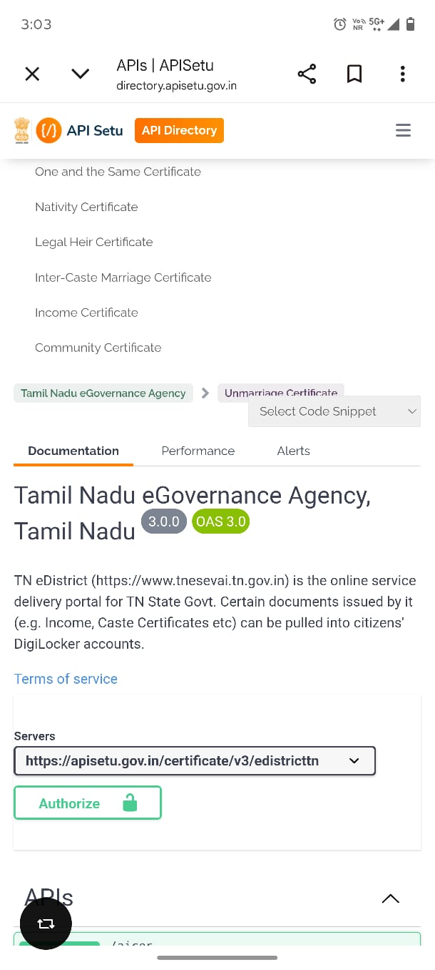
This is my Flow Chart
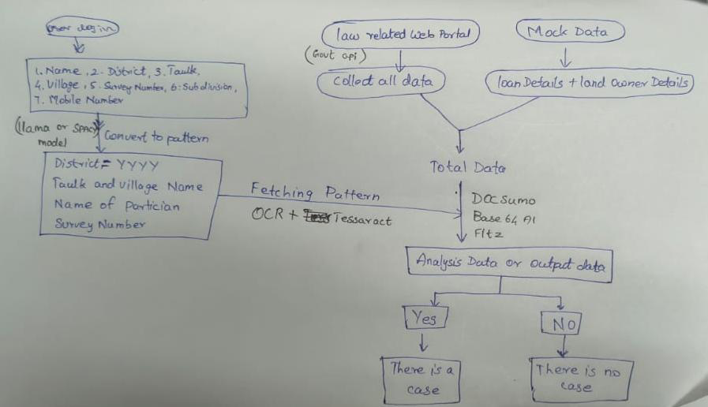
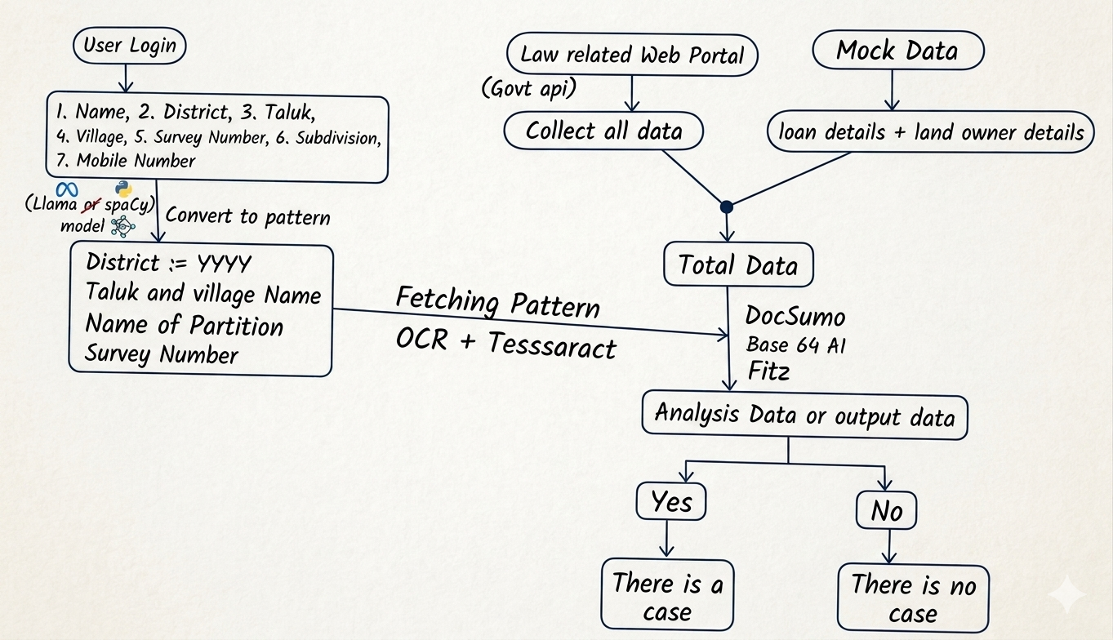
Sir, from which government official website can we get APIs? Also, does Indian Kanoon provide court case APIs on their side?

